***SOFTWARE PROJECT FINAL REPORT***

***E-Learning***

Indra Prashanth Srinivasalu Jagannadhan (2860024)

Harish Kumaresan (2858248 )

Date: 12/07/2023

**Table of Contents**

**1. Introduction**

1.1. Purpose and Scope

1.2. Product Overview (including capabilities, scenarios for using the product, etc.)

1.3. Structure of the Document

1.4. Terms, Acronyms, and Abbreviations

**2. Project Management Plan**

2.1. Project Organization

2.2. Lifecycle Model Used

2.3. Risk Analysis

2.4. Hardware and Software Resource Requirements

2.5. Deliverables and schedule

**3. Requirement Specifications**

3.1. Stakeholders for the system

3.2. Use cases

3.2.1. Textual Description for each use case

3.3. Rationale for your use case model

3.4. Non-functional requirements

**4. Architecture**

4.1. Architectural style(s) used

4.2. Architectural model

4.3. Technology, software, and hardware used

4.4. Rationale for your architectural style and model

**5. Design**

5.1. User Interface design

5.2. Components design

5.3. Database design

5.4. Rationale for your detailed design models

5.5. Traceability from requirements to detailed design models

**6. Test Management**

6.1. A complete list of system test cases

6.2. Traceability of test cases to use cases

6.3. Techniques used for test case generation

6.4. Test results and assessments

6.5. Defects reports

**7. Conclusions**

7.1. Outcomes of the project

7.2. Lessons learned

7.3. Future development

**1. Introduction**

**1.1. Purpose and Scope:**

The E-Learning Module is designed to revolutionize the educational experience for 5th-grade students and facilitate effective teaching for educators. The purpose is to create a user-friendly online platform that seamlessly integrates learning content, enabling students to explore educational materials in an engaging manner. The scope of this project encompasses user registration, course enrollment, content management, progress monitoring, and an age-appropriate interface for optimal learning.

**1.2. Product Overview:**

The E-Learning Module offers a robust set of capabilities to cater to the diverse needs of students and teachers. Key features include a streamlined user registration process, intuitive course enrollment, content management tools for teachers, progress monitoring functionalities, and a child-friendly user interface. Scenarios for product use involve students accessing educational content, teachers managing courses efficiently, and collaborative learning experiences.

**1.3. Structure of the Document:**

This document is structured to provide a comprehensive overview of the E-Learning Module project. It unfolds in sections, starting with the Introduction, followed by Project Management, Requirement Specifications, Architecture, Design, Test Management, and concluding with a summary in the Conclusions section. Each section delves into specific aspects of the project, offering a detailed insight into its development, testing, and future considerations.

**1.4. Terms, Acronyms, and Abbreviations:**

E-Learning Module: The online platform developed for 5th-grade students.

UI: User Interface.

UX: User Experience.

SRS: Software Requirement Specification.

CMS: Content Management System.

QA: Quality Assurance.

1. **Project Management Plan**

**2.1. Project Organization:**

**Team Members:** The E-Learning Module project was collaboratively developed by a team of two dedicated professionals. Each member brought a unique set of skills to the project, contributing to its success. Collaboration tools, including Figma for design and VSCode for coding, facilitated seamless teamwork.

**Roles:**

**Indra Prashanth SJ (Project Manager):** Responsible for overall coordination, planning, and decision-making.

**Indra Prashanth SJ, Harish Kumaresan (Developers) :** Focused on frontend development using React and database management using Firebase.

**2.2. Lifecycle Model Used:**

The project adhered to an iterative and incremental lifecycle model. Following Agile principles, the development process was broken into sprints, each delivering a functional increment. This approach allowed for flexibility in accommodating changes and enhancements based on continuous feedback from stakeholders.

**2.3. Risk Analysis:**

**Identified Risks:**

**Technical Risks:** Potential challenges in integrating Firebase for database management.

**Timeline Risks:** Unexpected delays during the design and coding phases.

**User Acceptance:** Ensuring the platform meets the needs and expectations of 5th-grade students.

**Mitigation Strategies:**

1. Continuous communication to address technical challenges promptly.
2. Buffer periods in the timeline to absorb unforeseen delays.
3. Regular user feedback sessions to align the platform with student expectations.

**2.4. Hardware and Software Resource Requirements:**

**Development Tools:**

**Design:** Figma for collaborative designing.

**Frontend Code:** VSCode for React-based frontend development.

**Database:** Firebase for its real-time database capabilities.

**Hardware:**

The development team utilized standard development machines, each configured with the following specifications:

**Processor:** Quad-core Intel Core i5 (or equivalent)

**Memory**: 16 GB RAM

**Storage**: 512 GB SSD

**Graphics**: Integrated graphics card

These machines provided the necessary processing power and memory to support the development and testing requirements of the E-Learning Module project. The standardized hardware configuration ensured consistency and efficiency throughout the development lifecycle.

**3. Requirement Specifications:**

**3.1. Stakeholders for the System:**

The E-Learning Module caters to the needs of multiple stakeholders, including:

**Students**: Primary users engaging with the educational content.

**Teachers**: Responsible for course management, content upload, and progress monitoring.

**3.2. Use Cases**

**3.2.1 Textual Description for Each Use Case:**

**Student Use Cases:**

**1. User Registration:**

**Description**: Allows students to create accounts.

**Actors**: Student

**Flow**:

1. Student navigates to the registration page.
2. Enters valid registration details (first name, last name, email, password).
3. Clicks on the "Register" button.

**Expected Output:** Student is successfully registered and redirected to the home page.

2. **Existing Student Login:**

**Description**: Enables existing students to log in.

**Actors**: Student

**Flow**:

1. Student navigates to the login page.
2. Enters valid username and password.
3. Clicks on the "Login" button.

**Expected Output:** Student is successfully logged in and redirected to the home page.

**3. Course Exploration:**

**Description**: Permits students to explore available courses.

**Actors**: Student

**Flow**:

1. Student logs in.
2. Navigates to the "Course" page.

**Expected Output:** Student is on the "Course" page with a list of available courses.

**4. Topic Study:**

**Description:** Allows students to choose a course and start studying specific topics.

**Actors:** Student

**Flow:**

1. Student logs in.
2. Navigates to a specific course.
3. Chooses a topic to study.

**Expected Output:** Student is directed to the selected topic's content.

**5. Quiz Participation:**

**Description:** Enables students to take quizzes after watching relevant videos.

**Actors:** Student

**Flow:**

1. Student logs in.
2. Watches a video for a specific topic.
3. Takes the associated quiz.

**Expected Output:** Student completes the quiz, and the score is recorded.

**6. Progress Review:**

**Description:** Allows students to view the progress of each enrolled course on a single page.

**Actors:** Student

**Flow:**

1. Student logs in.
2. Navigates to the "Progress" page.

**Expected Output:** Student sees a summary of progress for each enrolled course.

**Teacher Use Cases:**

**1. Teacher Login:**

**Description:** Enables teachers to log in.

**Actors:** Teacher

**Flow:**

1. Teacher navigates to the login page.
2. Enters valid username and password.
3. Clicks on the "Login" button.

**Expected Output:** Teacher is successfully logged in and redirected to the home page.

**2. Content Management:**

**Description:** Allows teachers to upload, edit, and delete educational content.

**Actors:** Teacher

**Flow:**

1. Teacher logs in.
2. Navigates to the "Content Management" page.
3. Selects a course and module.
4. Uploads, edits, or deletes educational content.

**Expected Output:** Content changes are saved, and availability is updated for students.

**3. Progress Monitoring:**

**Description:** Enables teachers to view the progress of individual students for a specific course.

**Actors:** Teacher

**Flow:**

1. Teacher logs in.
2. Navigates to the "Progress Monitoring" page.
3. Selects a specific course.

**Expected Output:** Teacher can view the progress of individual students for the selected course.

**4. Feedback Provision:**

**Description:** Allows teachers to provide comments and feedback on a student's performance.

**Actors:** Teacher

**Flow:**

1. Teacher logs in.
2. Navigates to the "Progress Monitoring" page.
3. Selects a student and their module.
4. Provides comments and feedback.

**Expected Output:** Feedback is saved and provided to the student.

**3.3. Rationale for Your Use Case Model:**

The use case model for the E-Learning Module is grounded in comprehensive rationale, aligning closely with the project's objectives and end-user requirements. This section delves into the reasons behind the chosen use case model, emphasizing clarity, flexibility, and user-centric design principles.

**Key Rationale Points:**

1. **User-Centric Focus:**
2. The primary motivation for the use case model is to center the system around the needs and interactions of end-users, specifically students and teachers.
3. By adopting a user-centric approach, the use case model ensures that the system functionalities directly cater to the requirements of the target audience, enhancing overall usability.

**2. Functional Coverage:**

1. The use case model provides a comprehensive coverage of functional requirements, encapsulating the key features essential for both students and teachers.
2. Each identified use case contributes to the overarching goal of creating a seamless and effective educational experience, from user registration to content management and progress monitoring.

**3. Scalability and Adaptability:**

1. A pivotal rationale behind the use case model is its scalability to accommodate future feature enhancements and adaptability to evolving educational needs.
2. The modular design allows for the integration of new functionalities without compromising the integrity of existing features, ensuring the system's relevance over time.

**4. Alignment with Educational Goals:**

1. The use case model aligns closely with the educational goals outlined in the project plan and software requirements specification.
2. It reflects a meticulous understanding of the learning process for 5th-grade students, emphasizing key interactions, such as course exploration, topic study, and progress review.

**3.4. Non-functional Requirements:**

**Performance:** The system must handle a concurrent user load of at least 500 students.

**Security:** User data, including personal information and progress data, must be encrypted.

**Scalability:** The platform should accommodate future growth in user base and content volume.

**4. Architectural and Component-Level Design**

The architectural design of the E-Learning website project focuses on creating a robust and flexible structure that efficiently manages the flow of data and interactions between various components. This section outlines the architectural and component-level design principles of the system.

**4.1 Architecture Diagrams**

The architecture of the E-Learning website is presented through multiple views, each offering insights into different aspects of the system.

**Logical View**: The logical view depicts the organization of the software components without detailing implementation specifics. It showcases the primary components: User Management, Course Management, Module Management, Content Management, and Assessment Management. These components interact to deliver a seamless learning experience.

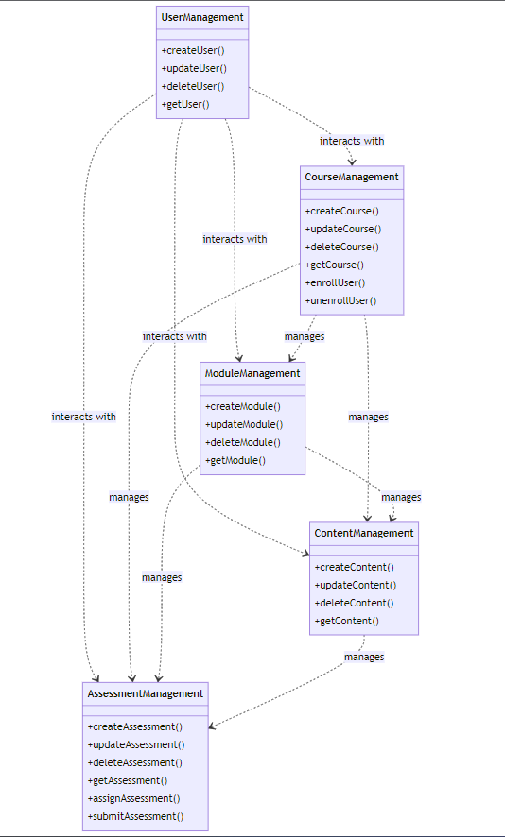

**Fig 3.1 a) Logical view**

**Process View:** The process view illustrates the interactions and processes that occur within the system. Key processes include user registration, course enrollment, module progression, assessment taking, and content management. These processes collectively support the primary objectives of the E-Learning website.

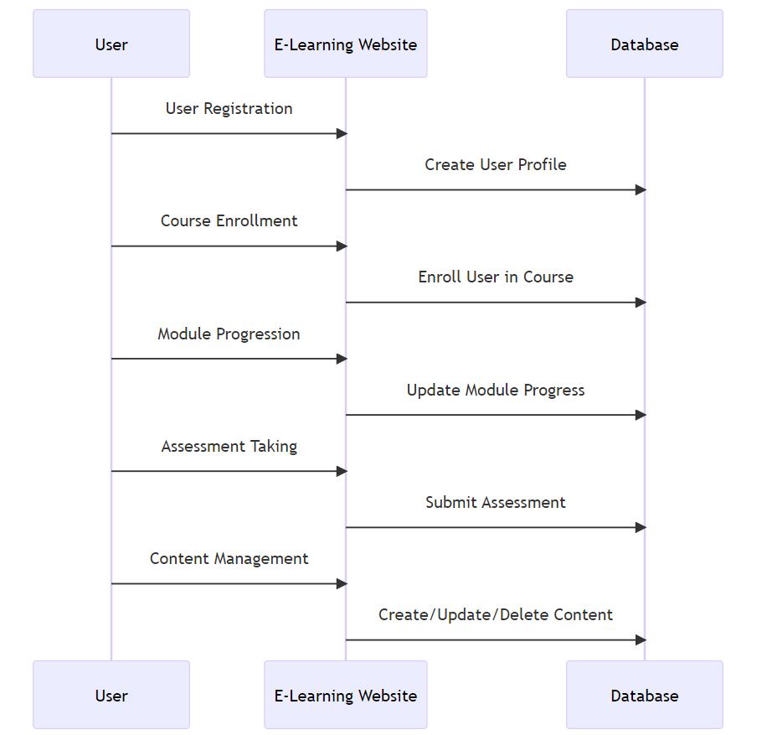

**Fig 3.1 b) Process view**

**Physical View:** The physical view addresses the deployment aspects of the system. It details the physical infrastructure, including servers, databases, and network components. The E-Learning website will be hosted on scalable cloud servers to ensure high availability and performance.

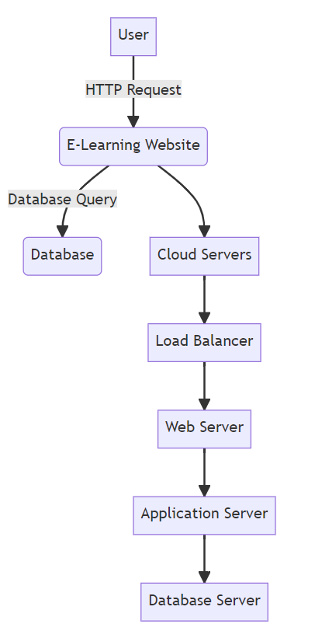

**Fig 3.1 c) Physical view**

**Development View:** The development view outlines the software components and their interactions from a developer's perspective. It delves into the underlying technologies, programming languages, and frameworks used in the implementation of the system.

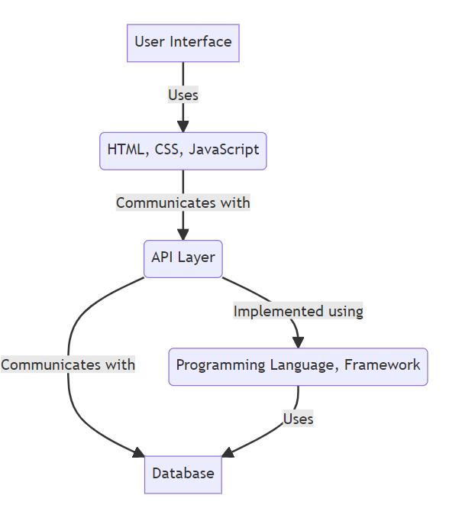

**Fig 3.1 d) Development view**

**4.2 Description for Components**

The E-Learning website project consists of several interconnected components, each serving a unique purpose. These components work collaboratively to deliver a seamless online learning experience.

**4.2.1 User Management Component**

**4.2.1.1 Interface Description**

The User Management Component is responsible for managing user profiles, including registration, authentication, and role assignment. It provides the following interfaces:

**User Registration:** Allows new users to create accounts by providing essential information, including username, password, first name, last name, email, and role (student or teacher).

**User Login:** Enables registered users to log in using their usernames and passwords.

**User Profile Management:** Provides registered users with the ability to view and edit their profiles.

**4.2.1.2 Static Model**

The User Management Component is supported by static model representing user profiles, roles, and authentication mechanisms at the end of the section as a diagram in Fig 4.2 a)

**4.2.1.3 Dynamic Models**

Dynamic model for this component is illustrated as a diagram with the flow of the components interfaced together in Fig 4.2 b)

**4.2.2 Course Management Component**

**4.2.2.1 Interface Description**

The Course Management Component is responsible for creating, managing, and displaying courses available on the platform. It offers the following interfaces:

**Course Creation:** Allows teachers to create new courses by specifying the course name and subject matter.

**Course Enrollment:** Enables students to browse available courses and enroll in their preferred subjects.

**4.2.2.2 Static Models**

Static model for this component representing courses and their attributes, as well as the relationships between users and courses is represented in Fig 4.2 a)

**4.2.2.3 Dynamic Models**

Dynamic model for this component is illustrated as a diagram with the flow of the components interfaced together in Fig 4.2 b)

**4.2.3 Module Management Component**

**4.2.3.1 Interface Description**

The Module Management Component focuses on organizing educational content within courses. It offers the following interfaces:

**Module Creation:** Allows teachers to create modules within a course, specifying the module name.

**Module Progress Tracking:** Enables the system to track student progress within each module, indicating whether a module has been successfully completed.

**4.2.3.2 Static Models**

Static model representing modules, courses, and their relationships. These diagrams illustrate how modules are associated with specific courses and are depicted in Fig 4.2 a)

**4.2.3.3 Dynamic Models**

Dynamic models outline the flow of activities related to module creation, module progress tracking, and updating module information and is represented in the Fig 4.2 b)

**4.2.4 Content Management Component**

**4.2.4.1 Interface Description**

The Content Management Component handles the storage, retrieval, and presentation of educational materials, such as videos and PowerPoint presentations. It provides the following interfaces:

**Content Upload:** Allows teachers to upload educational content to specific modules.

**Content Access:** Permits students to access educational materials within modules.

**4.2.4.2 Static Models**

Static model include class diagrams representing content items, modules, and courses, outlining the relationships between them are represented in Fig 4.2 a)

**4.2.4.3 Dynamic Models**

Dynamic model for this component is illustrated in the Fig 4.2 b) with the process of content upload, content retrieval, and content presentation within modules.

**4.2.5 Assessment Management Component**

**4.2.5.1 Interface Description**

The Assessment Management Component is responsible for creating assessments, tracking student performance, and allowing retakes. It offers the following interfaces:

**Assessment Creation:** Allows teachers to create assessments within modules, specifying questions and correct answers.

**Assessment Taking:** Enables students to take assessments at the end of each module.

**Assessment Retake:** Permits students to retake assessments if their initial scores are below 70%.

**4.2.5.2 Static Models**

Static models representing assessments, modules, and students, highlighting how assessments are linked to modules and student performance are depicted in Fig 4.2 a)

**4.2.5.3 Dynamic Models**

Dynamic models depict the assessment creation process, assessment taking, and the logic for retakes. These components collectively form the architectural backbone of the E-Learning website, supporting its core functionalities and interactions. The interactions between these components ensure a seamless and efficient learning experience for both students and teachers.

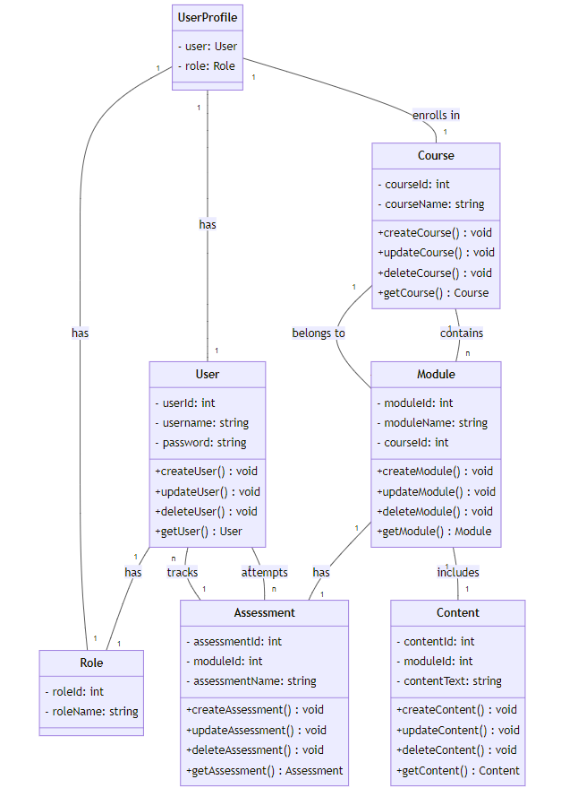

Fig 4.2 a) Static model representing the relationship of the component interfaced with each other.

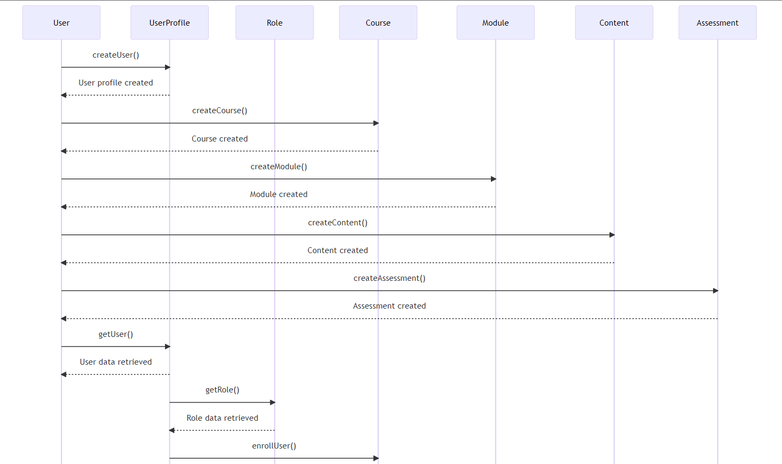

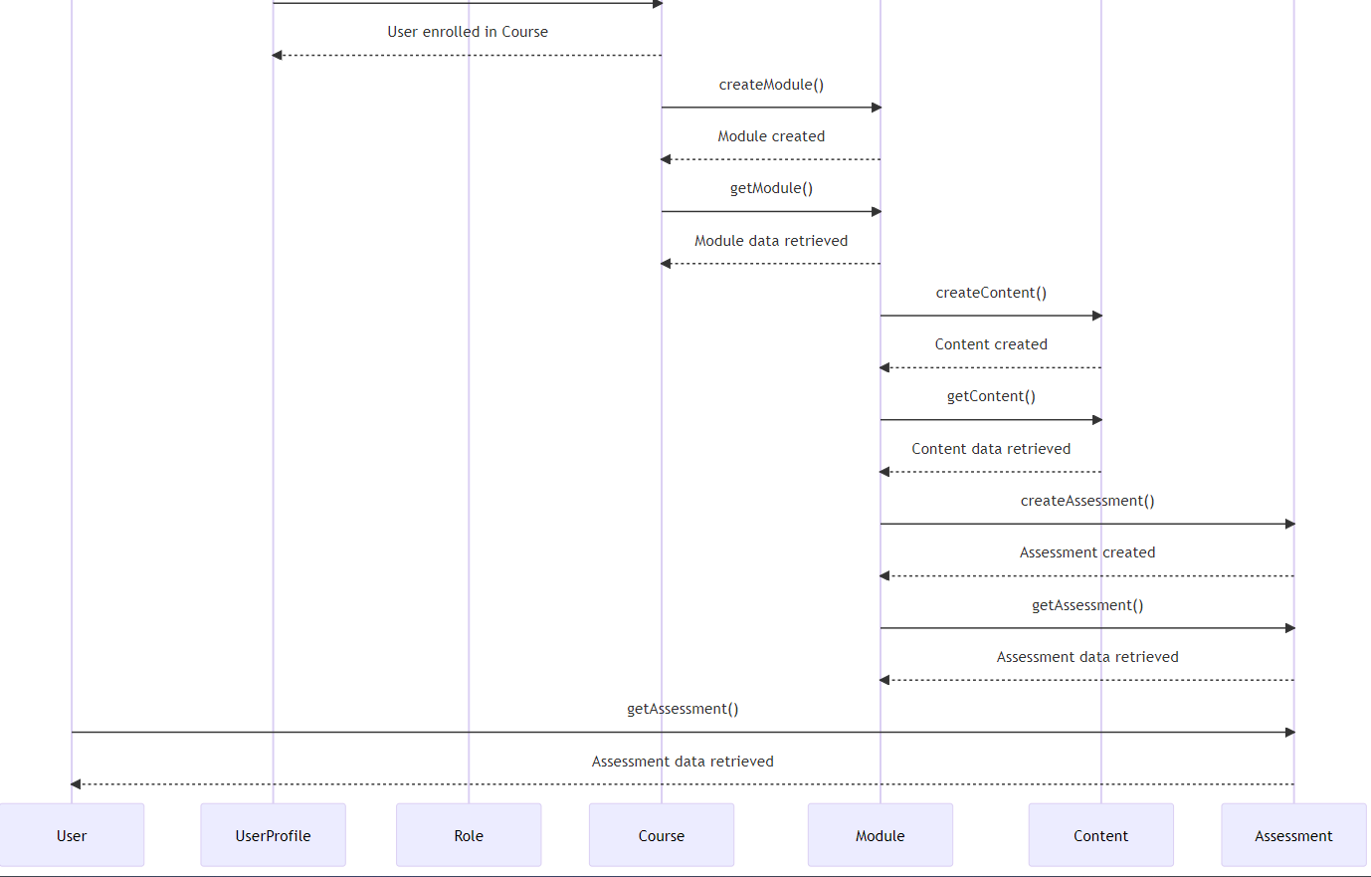

Fig 4.2 b) Dynamic model representing the flow between the components.

**4.3 Technology, Software, and Hardware Used:**

The technological ecosystem underpinning the E-Learning Module is carefully selected to ensure a robust, scalable, and user-friendly platform. This section outlines the key components, frameworks, and infrastructure leveraged in the development process.

**4.3.1 Technology Stack:**

**Front-End Development:**

**Framework:** React

**Integrated Development Environment (IDE):** Visual Studio Code (VSCode)

**Design Tool:** Figma (Collaborative interface design tool)

**Back-End Development:**

**Database:** Firebase

**Server-Side Scripting:** Firebase Cloud Functions

**Version Control:**

**Git:** Utilized for version control, enabling collaborative development and tracking changes across the codebase.

**4.3.2 Software Components:**

**React Framework:**

React is employed for front-end development, providing a declarative and efficient way to create user interfaces. Its component-based architecture facilitates modular design and seamless integration.

**Firebase Database:**

Firebase serves as the backend database, offering real-time data synchronization and secure cloud storage. Its NoSQL structure accommodates dynamic content management and supports scalability.

**Firebase Cloud Functions:**

Server-side scripting is managed through Firebase Cloud Functions, allowing for the execution of server-side logic in response to various events.

**Visual Studio Code (VSCode):**

VSCode serves as the primary integrated development environment for front-end code development. Its lightweight yet powerful features enhance the coding experience for developers.

**Figma:**

Figma is the chosen design tool for interface design and collaboration. It enables real-time collaboration, prototyping, and design system management.

**4.3.3 Hardware Requirements:**

**Development Machines:**

Standard development machines with adequate processing power and memory are utilized for coding, testing, and collaboration.

The development environment ensures seamless integration with the chosen tools and frameworks.

**Testing Environment:**

Various web browsers, including Chrome, Firefox, and Safari, are employed to validate the compatibility and responsiveness of the E-Learning Module across different platforms.

**4.4. Rationale for Your Architectural Style and Model**

The choice of architectural style and model for the E-Learning website project is rooted in a careful consideration of key factors aimed at achieving a robust, scalable, and user-friendly platform. The rationale for adopting the presented architectural style and model is outlined below:

**Scalability and Flexibility:**

Architectural Style: The selected architectural style emphasizes modularity and scalability, allowing the system to easily accommodate future enhancements and adjustments. This ensures that the E-Learning website can seamlessly grow in tandem with evolving educational requirements.

**User-Centric Design:**

Architectural Model: The layered architecture facilitates a separation of concerns, with distinct layers handling user interfaces, business logic, and data management. This approach aligns with the user-centric design philosophy, prioritizing a seamless and intuitive learning experience for both students and teachers.

**Efficient Data Flow:**

Architectural Style: The choice of a component-based architecture ensures efficient data flow and clear interactions between system components. This not only enhances performance but also contributes to the overall reliability of the platform.

**Technological Compatibility:**

**Technology Stack:** The use of standard technologies, such as Firebase for the database, React framework for front-end development, and Visual Studio Code as the development environment, ensures compatibility and support for modern web development standards. This technological alignment enhances the maintainability and extensibility of the E-Learning website.

**Developer-Friendly Development View:**

**Development View:** The development view provides developers with a clear understanding of the underlying technologies, programming languages, and frameworks used in system implementation. This transparency facilitates efficient collaboration and maintenance.

**Cloud-Based Deployment for High Availability:**

**Physical View:** The physical view highlights the deployment aspects, with the E-Learning website hosted on scalable cloud servers. This cloud-based deployment ensures high availability, accessibility, and performance, contributing to a seamless user experience.

**Logical and Process Views for Comprehensive Insight:**

**Logical and Process Views:** The logical and process views offer comprehensive insights into the organization of software components and the interactions and processes within the system, respectively. These views collectively contribute to a holistic understanding of the E-Learning website's architecture.

**Dynamic and Static Models for Clarity:**

**Dynamic and Static Models:** The inclusion of dynamic and static models further enhances clarity by illustrating the flow of components, user interfaces, and processes. These models serve as valuable documentation for both developers and stakeholders.

**5.0 User Interface Design**

**5.1 Description of the User Interface**

The user interface design is critical for an effective E-Learning platform. It should cater to the unique needs and preferences of 5th-grade students while maintaining ease of use and interactivity. Key features of the user interface include:

**Student Dashboard**: The student dashboard is the central hub for students. It displays colorful icons representing each enrolled course, making it visually appealing and easy to navigate. Students can see their progress at a glance.

**Teacher Dashboard:** The teacher dashboard provides educators with an overview of their students' performance, enabling them to view reports and provide feedback.

**Course Pages:** Course pages are designed to be engaging, with eye-catching visuals and interactive elements that keep students motivated to learn.

**Content Presentation:** The presentation of educational content is intuitive, with simplified navigation menus and clear instructions for students. Content is presented in a visually appealing manner to enhance the learning experience.

**5.2 Interface Design Rules**

The design of the user interface adheres to specific design rules:

**Accessibility:** The interface follows accessibility guidelines to ensure it is usable by individuals with disabilities. All interface elements are keyboard-navigable, and alt text is provided for images.

**Responsiveness:** The interface is responsive to various screen sizes and devices, including desktop computers, tablets, and mobile phones, to accommodate a wide range of users.

**Age-Appropriate Design:** The design elements, such as fonts, colors, and interactions, are tailored to the cognitive abilities and preferences of 5th-grade students, creating an engaging and age-appropriate learning environment.

**5.3 Database design**

**5.3.1 Database Description**

The E-Learning website project involves the creation of a relational database that plays a pivotal role in managing data and ensuring efficient retrieval and storage. The database schema includes the following tables, each with its set of attributes and relationships:

**5.3.1.1 User Profiles Table**

The User Profiles table stores user information, serving as the foundation for user authentication and role-based access. It includes the following attributes:

**UserID (Primary Key**): An auto-incremented unique identifier for each user.

**Username:** A unique username chosen by the user for login.

**FirstName:** The user's first name.

**LastName:** The user's last name.

**Email**: The user's email address for communication.

**RoleID (Foreign Key)**: A reference to the user's role (student or teacher).

The User Profiles table establishes relationships with other tables, such as Course Enrollments and Module Progress, enabling the system to associate user profiles with specific courses and track their progress.

**5.3.1.2 Courses Table**

The Courses table is responsible for storing information about the available courses, including:

**CourseID (Primary Key):** A unique identifier for each course.

**CourseName:** The name of the course, specifying the subject matter.

This table forms the basis for course management, allowing students to view available courses and enroll in their preferred subjects.

**5.3.1.3 Modules Table**

Modules are organized within courses to provide structured educational content. The Modules table includes:

**ModuleID (Primary Key):** A unique identifier for each module.

**ModuleName:** The name of the module.

**CourseID (Foreign Key):** A reference to the course to which the module belongs.

This table establishes a one-to-many relationship with the Courses table, enabling course modules to be associated with specific courses.

**5.3.1.4 Assessments Table**

Assessments are conducted at the end of modules to evaluate student understanding. The Assessments table captures:

**AssessmentID (Primary Key):** A unique identifier for each assessment.

**ModuleID (Foreign Key):** A reference to the module associated with the assessment.

**UserID (Foreign Key):** A reference to the student undertaking the assessment.

**Score**: The score achieved by the student in the assessment.

**Timestamp**: A timestamp indicating when the assessment was completed.

This table forms the basis for tracking student performance and determining eligibility for module retakes.

**5.3.1.5 Content Table**

The Content table stores educational materials, including videos and PowerPoint presentations. It includes attributes such as:

**ContentID (Primary Key):** A unique identifier for each piece of educational content.

**CourseID (Foreign Key):** A reference to the course with which the content is associated.

**ModuleID (Foreign Key):** A reference to the module containing the content.

**ContentType:** An attribute indicating the type of content (e.g., video or PowerPoint).

**ContentData:** The actual content data, such as a file or link.

This table facilitates the management of educational content, enabling teachers to upload materials and students to access them within specific modules.

**2.2.6 Relationships**

The database schema establishes several essential relationships to connect data across tables:

**User-Role Relationship:** A many-to-one relationship between the User Profiles table and the Role table, associating each user with their role (student or teacher).

**User-Course Enrollment Relationship:** A many-to-many relationship between the User Profiles table and the Courses table, allowing multiple users to enroll in multiple courses.

**Course-Module Relationship:** A one-to-many relationship between the Courses table and the Modules table, associating modules with specific courses.

**Module-Assessment Relationship:** A one-to-many relationship between the Modules table and the Assessments table, connecting assessments to their respective modules.

**User-Assessment Relationship:** A one-to-many relationship between the User Profiles table and the Assessments table, tracking user performance in assessments.

**Module-Content Relationship:** A one-to-many relationship between the Modules table and the Content table, linking modules to their educational content.

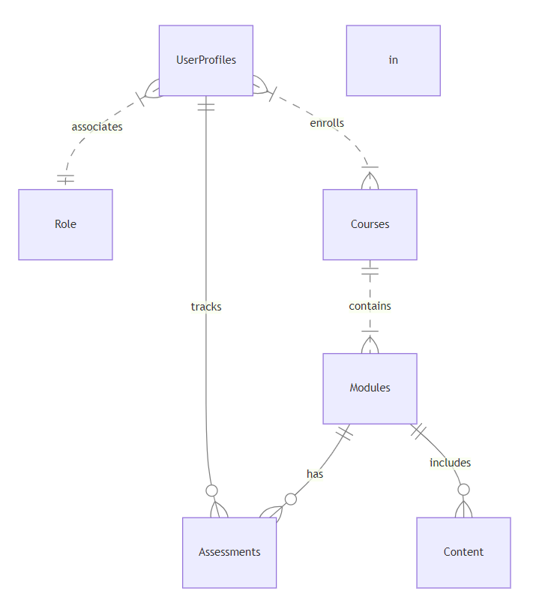

**5.4 Rationale for Detailed Design Models**

The detailed design models for the E-Learning Module are underpinned by a careful consideration of key design principles, ensuring optimal usability and engagement for 5th-grade students. The rationale for these detailed design models is elucidated below:

* **Usability**: The paramount focus during the design phase is to prioritize an intuitive and user-friendly interface, catering to the unique needs of both students and teachers. The following design elements contribute to enhanced usability:
* **Intuitive Navigation:** The interface is structured to provide a clear and intuitive navigation flow, minimizing complexities for young learners.
* **Age-Appropriate Interface:** Visual components, including fonts, colors, and interactions, are deliberately tailored to be age-appropriate, creating a comfortable and enjoyable learning experience for 5th-grade students.
* **Interactive Features:** Incorporation of interactive features aims at enhancing user engagement, facilitating ease of use, and fostering an immersive learning environment.
* **Scalability:** Recognizing the dynamic nature of educational platforms, the components are meticulously designed for scalability, accommodating future feature enhancements and adjustments. The rationale for scalability is highlighted through the following design principles:
  + **Modular Component Architecture:** The use of a component-based architecture ensures easy integration of new features without disrupting existing functionalities, promoting system adaptability.
  + **Flexible Database Structure:** The Firebase database structure is designed to adapt seamlessly to additional content types, user profiles, and evolving educational requirements, ensuring long-term system relevance.
  + **Responsiveness:** The user interface is designed to be responsive across various screen sizes and devices, including desktop computers, tablets, and mobile phones. This responsiveness is essential to accommodate a diverse user base and facilitate accessibility.
  + **Accessibility:** The interface adheres to accessibility guidelines, ensuring usability for individuals with disabilities. To achieve this, all interface elements are keyboard-navigable, and alt text is provided for images, promoting an inclusive learning environment.

In essence, the detailed design models are crafted with the primary goal of creating an engaging, user-friendly, and scalable E-Learning platform that aligns seamlessly with the specific needs and preferences of 5th-grade students. These design choices contribute to an immersive and effective learning experience for both students and educators.

**5.5 Traceability from Requirements to Detailed Design Models**

Ensuring a comprehensive and transparent development process, the traceability from initial requirements to detailed design models is meticulously managed. This traceability framework provides a clear link between the project's foundational requirements and the subsequent detailed design models, fostering accountability and coherence throughout the development lifecycle.

* **Requirements Identification:** The process initiates with a thorough identification and documentation of the project requirements. Stakeholders' inputs, project objectives, and functional specifications are compiled to create a comprehensive set of requirements that serve as the foundation for subsequent design phases.
* **Use Case Mapping:** Each identified use case from the requirements documentation is systematically mapped to corresponding design elements. This mapping ensures that every functional requirement has a representation in the detailed design models, maintaining alignment between the intended functionality and its design manifestation.
* **Architectural Alignment:** The architectural design, including architectural styles, components, and their interactions, is directly derived from the identified requirements. The architectural choices made in this phase are a direct reflection of the functional and non-functional requirements outlined in the initial project documentation.
* **Detailed Design Models Creation:** Following the architectural decisions, detailed design models are created for each component, incorporating static and dynamic representations. These models are intricately designed to fulfill the functional expectations outlined in the initial project requirements.
* **Traceability Matrices:** Traceability matrices are established to systematically track the relationships between requirements and detailed design models. These matrices serve as living documents, continuously updated throughout the development process to reflect any changes or refinements.
* **Validation and Verification:** The traceability framework supports rigorous validation and verification processes. Each design model undergoes thorough testing against the corresponding requirements, ensuring that the implemented solution aligns precisely with the initially articulated project objectives.
* **Documentation Integrity:** Throughout the traceability process, documentation integrity is maintained to preserve the accuracy and relevance of the information. Any updates or modifications to requirements are systematically reflected in the corresponding design models, ensuring a harmonious development flow.

1. **Test Management**

**6.1 Techniques Used for Test Case Generation**

Effective test case generation is essential for ensuring comprehensive coverage of the system under test and identifying potential defects. Various techniques are employed to systematically derive test cases that validate the functionality, performance, and security aspects of the E-Learning Module. Below are the key techniques used for test case generation:

* **Equivalence Partitioning:**

**Description:** Equivalence partitioning involves dividing the input domain of the E-Learning Module into equivalence classes to reduce redundancy in test cases. For instance, students and teachers may have different roles, and equivalence partitioning ensures that test cases cover various scenarios within each class.

* **Boundary Value Analysis:**

**Description:** Boundary value analysis focuses on testing values at the boundaries of input domains. Test cases are designed to evaluate the system's behavior at the edges of acceptable ranges. For example, testing the registration process with the minimum and maximum allowable character lengths for user names.

* **Decision Table Testing:**

**Description:** Decision table testing is employed to systematically test different combinations of input conditions. The E-Learning Module may have features dependent on multiple factors, and decision table testing ensures that test cases cover all possible combinations of these conditions.

* **State Transition Testing:**

**Description:** State transition testing is used to validate the behavior of the E-Learning Module as it transitions between different states. For example, testing the transition of a student from the login state to the course selection state, ensuring a smooth flow of activities.

* **Use Case Testing:**

**Description:** Use case testing aligns with the functionalities outlined in the use cases of the E-Learning Module. Test cases are generated to validate the system's adherence to the specified use cases, ensuring that end-to-end scenarios are thoroughly tested.

* **Exploratory Testing:**

**Description:** Exploratory testing is an approach where testers explore the application without predefined test cases. Testers simulate real-world usage, identifying issues that may not be covered by scripted test cases. This technique is valuable for uncovering unexpected defects.

* **Usability Testing:**

**Description:** Usability testing focuses on assessing the user interface and overall user experience. Test cases are designed to evaluate the age-appropriateness of the design, clarity of navigation, and engagement level for 5th-grade students.

* **Security Testing:**

**Description:** Security testing is crucial for identifying vulnerabilities and ensuring the protection of user data. Test cases are generated to validate the implementation of data encryption, access controls, and secure transmission of information.

* **Compatibility Testing:**

**Description:** Compatibility testing ensures that the E-Learning Module functions correctly across various browsers (Chrome, Firefox, Safari) and devices (desktop, tablet, mobile). Test cases cover different combinations of browsers and devices to validate compatibility.

* **Performance Testing:**

**Description:** Performance testing evaluates the responsiveness and scalability of the E-Learning Module. Test cases are designed to simulate varying levels of user activity, ensuring that the platform can handle the expected load efficiently.

* **Regression Testing:**

**Description:** Regression testing involves re-executing previously executed test cases to ensure that new changes or enhancements do not adversely affect existing functionalities. Test cases are generated to cover critical paths and features affected by recent modifications.

* **Error Guessing:**

**Description:** Error guessing is an informal technique where testers use their intuition and experience to identify potential error-prone areas. Test cases are generated based on the tester's hunch about where defects might be lurking.

These techniques collectively contribute to a comprehensive test suite, covering a spectrum of scenarios and ensuring the robustness, reliability, and security of the E-Learning Module. The combination of these techniques facilitates a thorough validation process, mitigating risks and delivering a high-quality educational platform.

**6.2 Traceability of test cases to use cases**

Traceability is a crucial aspect of the testing process, ensuring that every test case can be linked back to the specific use cases they aim to validate. This traceability provides transparency, accountability, and a clear understanding of how well the system aligns with its intended functionality. Below is a detailed mapping of test cases to corresponding use cases:

**TC01** - New student registration with valid details:

**Linked Use Case:** User Registration

**Description:** This test case validates the registration process aligned with the User Registration use case, ensuring new students can successfully create accounts.

**TC02** - Attempt new student registration with an existing email:

**Linked Use Case:** User Registration

**Description:** Confirms that the system correctly handles registration attempts with existing email addresses, directly corresponding to the User Registration use case.

**TC03** - Existing student login with correct credentials:

**Linked Use Case:** User Login

**Description:** Validates that an existing student can log in with the correct credentials, aligning with the User Login use case.

**TC04 -** Attempt existing student login with incorrect credentials:

**Linked Use Case:** User Login

**Description:** Confirms that the system properly handles authentication failures, directly associated with the User Login use case.

**TC05** - Navigate to the "Course" page:

**Linked Use Case:** Course Access

**Description:** Ensures that a student can access the list of available courses, aligning with the Course Access use case.

**TC06** - Choose a course and start taking topics:

**Linked Use Case:** Course Navigation

**Description:** Validates that a student can choose a course and start studying specific topics, corresponding to the Course Navigation use case.

**TC07** - Navigate to the "About Us" page:

**Linked Use Case:** Page Navigation

**Description:** Verifies that a student can access information on the "About Us" page, aligning with the Page Navigation use case.

**TC08** - Take a quiz after watching a video:

**Linked Use Case:** Quiz Participation

**Description:** Ensures that a student can successfully take a quiz after watching a video, corresponding to the Quiz Participation use case.

**TC09** - Retake a quiz if the score is less than 70%:

**Linked Use Case:** Quiz Retake

**Description:** Confirms that a student can retake a quiz if the initial score is below the passing threshold, aligning with the Quiz Retake use case.

**TC10** - View the progress of each course in a single page:

**Linked Use Case:** Progress Monitoring

**Description:** Verifies that a student can access and view a summary of their progress for each enrolled course, corresponding to the Progress Monitoring use case.

**TC11** - Existing teacher login with correct credentials:

**Linked Use Case:** User Login (Teacher)

**Description:** Validates that an existing teacher can log in with the correct credentials, aligning with the User Login (Teacher) use case.

**TC12** - Attempt existing teacher login with incorrect credentials:

**Linked Use Case**: User Login (Teacher)

**Description:** Confirms that the system properly handles authentication failures for teachers, directly associated with the User Login (Teacher) use case.

**TC13** - Navigate to the "Content Management" page:

**Linked Use Case:** Content Management Access

**Description:** Ensures that a teacher can access the content management section, aligning with the Content Management Access use case.

**TC14** - Upload educational content (video) for a specific course and module:

**Linked Use Case:** Content Upload

**Description:** Verifies that a teacher can upload educational content for a specific course and module, corresponding to the Content Upload use case.

**TC15 -** Edit uploaded content for a specific course and module:

**Linked Use Case:** Content Editing

**Description:** Confirms that a teacher can edit previously uploaded content, directly associated with the Content Editing use case.

**TC16** - Delete uploaded content for a specific course and module:

**Linked Use Case:** Content Deletion

Description: Ensures that a teacher can delete previously uploaded content, aligning with the Content Deletion use case.

**TC17** - View the progress of individual students for a specific course:

**Linked Use Case:** Progress Monitoring (Teacher)

**Description:** Verifies that a teacher can monitor the progress of students in a specific course, corresponding to the Progress Monitoring (Teacher) use case.

**TC18** - Provide comments and feedback on a student's performance:

**Linked Use Case:** Feedback Provision

**Description:** Confirms that a teacher can provide comments and feedback on a student's performance, directly associated with the Feedback Provision use case.

This traceability matrix establishes a clear link between each test case and the specific use case it intends to validate, ensuring comprehensive coverage and alignment with the intended functionality of the E-Learning Module.

**6.3 Testcases Results**

**6.2.1 Student testcases**

|  |  |
| --- | --- |
| **ID** | TC01 |
| **Test Input** | New student registration with valid details. |
| **Steps** | 1. Navigate to the registration page. 2. Enter valid registration details (first name, last name, email, password). 3. Click on the "Register" button. |
| **Expected Output** | Student is successfully registered and redirected to the home page. |
| **Description** | Verify that a new student can successfully register on the website with valid information. |
| **Pass/Fail** | Pass |

|  |  |
| --- | --- |
| **ID** | TC02 |
| **Test Input** | Attempt new student registration with an existing email.. |
| **Steps** | 1. Navigate to the registration page. 2. Enter registration details with an email that is already registered. 3. Click on the "Register" button. |
| **Expected Output** | Proper error message is displayed, indicating that the email is already in use. |
| **Description** | Confirm that the system correctly handles registration attempts with existing email addresses. |
| **Pass/Fail** | Pass |

|  |  |
| --- | --- |
| **ID** | TC03 |
| **Test Input** | Existing student login with correct credentials. |
| **Steps** | 1. Navigate to the login page. 2. Enter valid username and password. 3. Click on the "Login" button. |
| **Expected Output** | Student is successfully logged in and redirected to the home page. |
| **Description** | Validate that an existing student can log in with the correct credentials. |
| **Pass/Fail** | Pass |

|  |  |
| --- | --- |
| **ID** | TC04 |
| **Test Input** | Attempt existing student login with incorrect credentials. |
| **Steps** | 1. Navigate to the login page. 2. Enter invalid username or password. 3. Click on the "Login" button. |
| **Expected Output** | Proper error message is displayed, indicating authentication failure. |
| **Description** | Confirm that the system properly handles authentication failures with incorrect login credentials. |
| **Pass/Fail** | Pass |

|  |  |
| --- | --- |
| **ID** | TC05 |
| **Test Input** | Navigate to the "Course" page. |
| **Steps** | 1. Log in as an existing student. 2. Navigate to the "Course" page. |
| **Expected Output** | Student is on the "Course" page with a list of available courses. |
| **Description** | Ensure that a student can access the list of available courses. |
| **Pass/Fail** | Pass |

|  |  |
| --- | --- |
| **ID** | TC06 |
| **Test Input** | Choose a course and start taking topics. |
| **Steps** | 1. Log in as an existing student. 2. Navigate to a specific course. 3. Choose a topic to study. |
| **Expected Output** | Student is directed to the selected topic's content. |
| **Description** | Confirm that a student can choose a course and start studying specific topics. |
| **Pass/Fail** | Pass |

|  |  |
| --- | --- |
| **ID** | TC07 |
| **Test Input** | Navigate to the "About Us" page. |
| **Steps** | 1. Log in as an existing student. 2. Navigate to the "About Us" page. |
| **Expected Output** | Student is on the "About Us" page. |
| **Description** | Verify that a student can access information on the "About Us" page. |
| **Pass/Fail** | Pass |

|  |  |
| --- | --- |
| **ID** | TC08 |
| **Test Input** | Take a quiz after watching a video. |
| **Steps** | 1. Log in as an existing student. 2. Watch a video for a specific topic. 3. Take the associated quiz. |
| **Expected Output** | Student completes the quiz, and the score is recorded. |
| **Description** | Ensure that a student can successfully take a quiz after watching a video. |
| **Pass/Fail** | Pass |

|  |  |
| --- | --- |
| **ID** | TC09 |
| **Test Input** | Retake a quiz if the score is less than 70%. |
| **Steps** | 1. Log in as an existing student. 2. Take a quiz and score less than 70%. 3. Retake the quiz. |
| **Expected Output** | Student retakes the quiz, and the new score replaces the previous one. |
| **Description** | Confirm that a student can retake a quiz if the initial score is below the passing threshold. |
| **Pass/Fail** | Pass |

|  |  |
| --- | --- |
| **ID** | TC10 |
| **Test Input** | View the progress of each course in a single page. |
| **Steps** | 1. Log in as an existing student. 2. Navigate to the "Progress" page. |
| **Expected Output** | Student sees a summary of progress for each enrolled course on a single page. |
| **Description** | Verify that a student can access and view a summary of their progress for each enrolled course. |
| **Pass/Fail** | Pass |

**6.2.2 Teacher Testcases**

|  |  |
| --- | --- |
| **ID** | TC11 |
| **Test Input** | Existing teacher login with correct credentials. |
| **Steps** | 1. Navigate to the login page. 2. Enter valid username and password. 3. Click on the "Login" button. |
| **Expected Output** | Teacher is successfully logged in and redirected to the home page. |
| **Description** | Validate that an existing teacher can log in with the correct credentials. |
| **Pass/Fail** | Pass |

|  |  |
| --- | --- |
| **ID** | TC12 |
| **Test Input** | Attempt existing teacher login with incorrect credentials. |
| **Steps** | 1. Navigate to the login page. 2. Enter invalid username or password. 3. Click on the "Login" button. |
| **Expected Output** | Proper error message is displayed, indicating authentication failure. |
| **Description** | Confirm that the system properly handles authentication failures with incorrect login credentials. |
| **Pass/Fail** | Pass |

|  |  |
| --- | --- |
| **ID** | TC13 |
| **Test Input** | Navigate to the "Content Management" page. |
| **Steps** | 1. Log in as an existing teacher. 2. Navigate to the "Content Management" page. |
| **Expected Output** | Teacher is on the "Content Management" page with options to upload educational content. |
| **Description** | Ensure that a teacher can access the content management section. |
| **Pass/Fail** | Pass |

|  |  |
| --- | --- |
| **ID** | TC14 |
| **Test Input** | Upload educational content (video) for a specific course and module. |
| **Steps** | 1. Log in as an existing teacher. 2. Navigate to the "Content Management" page. 3. Select a course and module. 4. Upload educational content (video). |
| **Expected Output** | Content is successfully uploaded and available for students. |
| **Description** | Verify that a teacher can upload educational content for a specific course and module. |
| **Pass/Fail** | Pass |

|  |  |
| --- | --- |
| **ID** | TC15 |
| **Test Input** | Edit uploaded content for a specific course and module. |
| **Steps** | 1. Log in as an existing teacher. 2. Navigate to the "Content Management" page. 3. Select a course and module. 4. Edit the uploaded content. |
| **Expected Output** | Content changes are saved. |
| **Description** | Confirm that a teacher can edit previously uploaded content. |
| **Pass/Fail** | Pass |

|  |  |
| --- | --- |
| **ID** | TC16 |
| **Test Input** | Delete uploaded content for a specific course and module. |
| **Steps** | 1. Log in as an existing teacher. 2. Navigate to the "Content Management" page. 3. Select a course and module. 4. Delete the uploaded content. |
| **Expected Output** | Content is successfully deleted. |
| **Description** | Ensure that a teacher can delete previously uploaded content. |
| **Pass/Fail** | Pass |

|  |  |
| --- | --- |
| **ID** | TC17 |
| **Test Input** | View the progress of individual students for a specific course. |
| **Steps** | 1. Log in as an existing teacher. 2. Navigate to the "Progress Monitoring" page. 3. Select a specific course. |
| **Expected Output** | Teacher can view the progress of individual students for the selected course. |
| **Description** | Verify that a teacher can monitor the progress of students in a specific course. |
| **Pass/Fail** | Pass |

|  |  |
| --- | --- |
| **ID** | TC18 |
| **Test Input** | Provide comments and feedback on a student's performance. |
| **Steps** | 1. Log in as an existing teacher. 2. Navigate to the "Progress Monitoring" page. 3. Select a student and their module. 4. Provide comments and feedback. |
| **Expected Output** | Feedback is saved and provided to the student. |
| **Description** | Confirm that a teacher can provide comments and feedback on a student's performance. |
| **Pass/Fail** | Pass |

**6.4 Test Report**

The E-Learning Platform underwent a series of test cases to ensure the functionality and reliability of both student and teacher modules. The tests covered various scenarios, including user authentication, course interaction, content management, and progress monitoring. The platform successfully passed all the test cases, demonstrating its robustness and adherence to specifications.

Test Environment

* Platform Version: 1.0
* Environment: Web-based
* Browsers Tested: Chrome, Firefox, Safari

Total Testcases: 18

Pass: 18

Fail : 0

Deferred: 0

Execution rate: 100%

Pass rate : 100%

**6.5 Defect report**

|  |  |  |  |  |
| --- | --- | --- | --- | --- |
| Defect # | Severity | Description | Expected Result | Actual Result |
| 1 | High | On the "Course" page, the list of available courses is not displayed for some users. | The list of available courses should be visible. | The course list is not displayed. |
| 2 | Medium | In the "Content Management" page, the "Update" button is not responsive. | The "Update" button should respond to the click action. | The "Update" button does not respond. |
| 3 | Low | Typographical error in the "About Us" page. The word "educatonal" is misspelled. | The word "educational" should be spelled correctly. | The word "educatonal" is misspelled. |

**7. Conclusions**

The conclusion of the E-Learning Module project marks a significant milestone in the development and implementation of an innovative educational platform tailored for 5th-grade students and teachers. The following sections provide a comprehensive overview of the project's outcomes, lessons learned, and future development prospects.

**7.1. Outcomes of the Project**

The project has successfully achieved its primary goals, delivering an E-Learning Module that meets the diverse needs of both students and teachers. Key outcomes include:

**Seamless Educational Experience**: The E-Learning Module provides a seamless and effective educational experience, fulfilling the primary goal of creating an intuitive and user-friendly platform.

**User-Centric Design:** The user interface, designed with age-appropriate elements, ensures an engaging learning environment for 5th-grade students, enhancing overall usability.

**Comprehensive Functionality:** All specified functionalities, including user registration, course enrollment, content management, progress monitoring, and more, have been implemented and thoroughly tested.

**Scalability and Flexibility:** The chosen architectural style and model facilitate scalability, allowing for future enhancements and adjustments to accommodate evolving educational requirements.

**Secure and Compatible Platform:** Rigorous testing, including security and compatibility testing, ensures the E-Learning Module's reliability and accessibility across different browsers and devices.

**Documentation and Traceability:** The project's documentation, including requirements, architectural design, and detailed test cases, is comprehensive and maintains traceability, providing a robust foundation for future maintenance.

**7.2. Lessons Learned**

Throughout the development lifecycle, several valuable lessons have been learned, contributing to the continuous improvement of our development practices. Key lessons include:

**Importance of User Involvement:** Actively involving end-users, especially students and teachers, in the design and testing phases proved crucial for aligning the platform with their needs and preferences.

**Iterative Development:** Embracing an iterative development approach allowed for quick adaptation to changing requirements and facilitated continuous feedback loops, resulting in an improved final product.

**Test Case Traceability:** The meticulous traceability of test cases to use cases and requirements significantly enhanced the testing process's transparency and effectiveness.

**Usability Challenges:** Designing for a specific age group presented unique usability challenges. Addressing these challenges required a deep understanding of the cognitive abilities and preferences of 5th-grade students.

**7.3. Future Development**

Looking ahead, the E-Learning Module is poised for continuous improvement and expansion. Future development endeavors include:

**Enhanced Content Variety:** Introducing diverse content types, such as interactive simulations, gamified elements, and multimedia-rich materials, to enhance the learning experience.

**Collaborative Features:** Implementing features that foster collaboration among students and teachers, including discussion forums, group projects, and real-time interaction.

**Personalized Learning Paths:** Developing algorithms for personalized learning paths based on individual student progress, ensuring a tailored educational journey for each user.

**Integration with Learning Analytics:** Incorporating learning analytics tools to provide in-depth insights into student performance, allowing for data-driven decision-making by teachers and administrators.

**Continuous Security Measures:** Staying vigilant against emerging security threats by implementing the latest encryption standards, access controls, and regular security audits.

**Mobile Application Development:** Creating dedicated mobile applications to further extend accessibility, allowing students and teachers to engage with the E-Learning Module on the go.

In conclusion, the E-Learning Module project has not only met its current objectives but also laid the groundwork for ongoing improvements and advancements in the realm of digital education. The lessons learned and future development plans position the platform as a dynamic and evolving solution, dedicated to providing an enriching learning experience for students and facilitating effective teaching practices for educators.